Explore Weather Trends Project

***By Ahmed Eweed***

Data Extraction:

Done by using SQL on my workspace

Results:

City level data of “Cairo”

SELECT *

FROM city_data

WHERE city='Cairo' AND country='Egypt';

City level data of “Berlin”

SELECT *

FROM city_data

WHERE city ='Berlin'

AND country='Germany'

AND year BETWEEN '1808'

AND '2013';

City level data of “New York”

SELECT *

FROM city_data

WHERE city ='New York'

AND country='United States'

AND year BETWEEN '1808'

AND '2013';

City level data of “London”

SELECT *

FROM city_data

WHERE city ='London'

AND country='United Kingdom'

AND year BETWEEN '1808'

AND '2013';

Global data around the world

SELECT *

FROM global_data

WHERE year BETWEEN '1808' AND '2013';

Moving Average:

Done by using Excel and 10-year moving average because a decade is a good measure to observe changes in weather

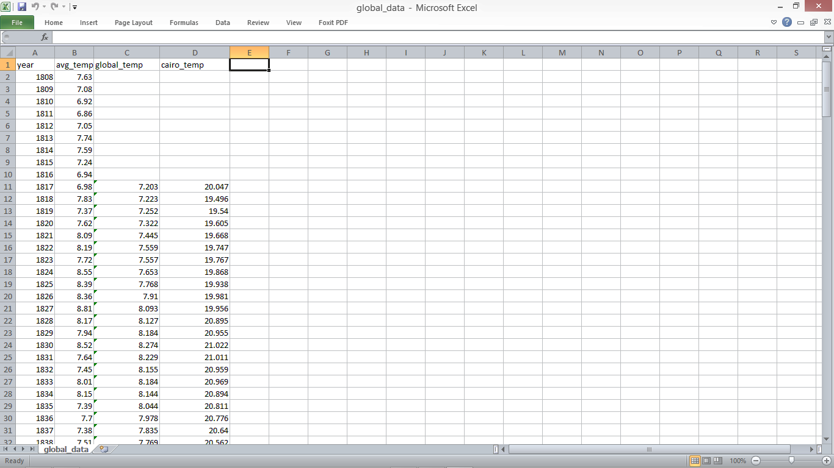

Line chart:

Done by Google Sheets

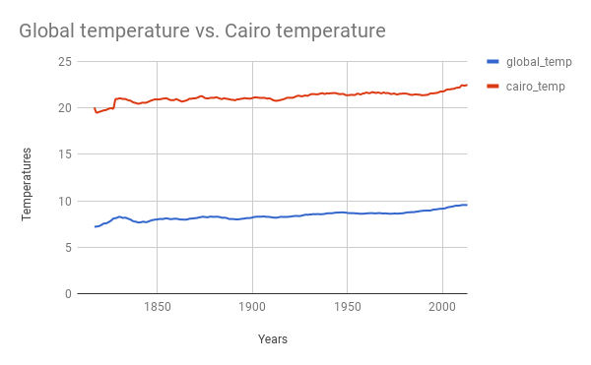

Observation:

1- Overall temperature in Cairo is higher than the global average with more than 10 degrees on average.

2- Cairo temperature has fallen approximately between 1815-1825 under 20 degree on average and then rose again and that’s the only drop in temperature in the recorded temperature since then. At the same time global temperature was rising

3- Earth’s overall temperature along with Cairo is rising by 1-2 degrees every 50 years until the last 50 years when it rose over 3 degrees in less than 20 years

4- it’s expected that the global temperature will continue to rise in the coming years by 2 or more degrees above the average temperature now

Correlation coefficient:

Equations from

“<https://www.investopedia.com/terms/c/correlationcoefficient.asp> “

=Covariance(x, y)/STD(x)*STD(y)

$$cov\left(x,y\right)=\sum_{i=1}^{N}{\frac{(xi-x')(yi-y')}{N-1}}$$

STD(x) = $\sqrt{\frac{ε(x-x')2}{n-1}}$

And for the sample provided it will be 0.932544

Which means they are positively correlated meaning that if one object value is raised the other will rise accordingly

Cities around the world:

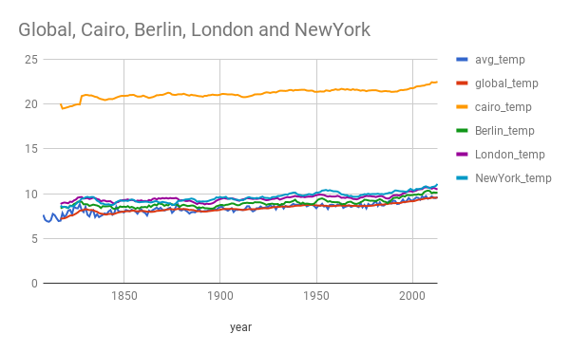

It’s really ambiguous because cities temperatures are similar

But they all share the rising up behavior and the consistent steady margin around the global average and not beneath it

It was fun observing and playing with these numbers and visualizations!

I hope to learn more so I can understand more about things I see every day.